**Stats Exam 4**

**Paired-t and RM ANOVA**

Explain the difference between repeated versus matched design

* Explain the advantages and challenges of creating repeated designs
* Explain the advantages and challenges of creating matched design

paired sample t test is where you take the difference score and run a t test on that, then once you have all the difference scores you calculate some variance of the difference scores, find the mean difference, then you know if its significantly different than no difference

* Useful for avoiding order effects
* If one person misses, all the data for that subject has to be thrown out
* The error term that’s part of the subject term is now accounted for so it doesn’t go in the denominator when calculating the F
* More power to detect effects
* Sensitive to sphericity violations, which increase Type 1 error

Explain both in words and visually the difference in the error term of the RM ANOVA as is compares to the independent ANOVA

(This is the differences in the pie)

* Provide thorough explanation of why this design is more powerful
* Give a scenario when the RM ANOVA is equally powered to an independent ANOVA

If your RM ANOVA violates sphericity you lose the RM component of the design. If you had to use the Univariate Classical Approach to do pairwise comparisons you would be losing the structure of the ANOVA and the power associated with it

How does the two-way RM ANOVA differ from the two-way independent ANOVA?

* Explain the error terms differences

Within error terms: SSsub, SSe1, SSe2, SSe1x2 and those all add up to SSw

What are the assumptions of the RM ANOVA?

* How are these assumptions the same and different from the independent ANOVA?
  + Explain sphericity both visually and verbally. Why is it a critical assumption?
    - Provide details as to why we only have two levels

**Sphericity:** Whether the variance of the differences between treatments is different

* The RM ANOVA subtracts out the individual differences so if sphericity is violated you can’t subtract out these values effectively and you lose power

**Why is there no sphericity between two**: you compare multiple correlations

**Why is there sphericity in an interaction?:** you’re correlating the changes within one effect to the changes in another effect

* How do we test for them? Mauchly’s test
  + How do we adjust for them if they are violated?
    - Explain what epsilon is, what we use it for, and know that there are two methods (GG and HF) and their levels of conservativeness

GG is the most common- is marginally conservative

HF is more conservative

Epsilon is calculated using DF, the more you violate the more it reduces your DF

* + - * What are the benefits and disadvantages of making these adjustments when the RM ANOVA assumptions are violated?

You decrease type 1 by correcting

You lose DFs, so you lose power

Modern approach: if you violate sphericity you don’t need to throw out the with-in subjs design, you can use fractional dfs

**Follow-up Tests for RM Design**

Explain the ways to follow-up two-way repeated measure ANOVA for planned and unplanned comparisons

* How do assumption violations affect your ability to follow up in two-way RM ANOVAs?
  + Explain the difference between three paths (assuming sphericity/univariate, assuming a violation of sphericity/multivariate, assuming a violation of sphericity/univariate)
    - Explain the error terms you would use for each pathway
    - Put them on a continuum from anti-conservatism to conservatism and explain why
      * What are the benefits and disadvantages of each pathway

Modern and MANOVA you can run contrasts on and use correction

The univariate approach you can only use pairwise and it is more conservative

Modern - uses the error term from the RM ANOVA, can correct for HOV violations but not for sphericity violations

MANOVA – uses smaller more conservative DF, less powerful but more conservative than Modern

Univariate – runs pairwise comparisons only, inflates type II

**error terms when following up interaction:**

if you’re following up a main effect -> use the error term from that row in the table

if you’re following up an interaction -> use the error term from the interaction row on the table

**unpacking an interaction:**

test the hypotheses -> you want to see what is driving the result; can be any combination of tests we’ve learned up to now

Don’t worry about the MANOVA, focus on the modern approach; understand why you follow up in an efficient way

Two-Way RM ANOVA Table

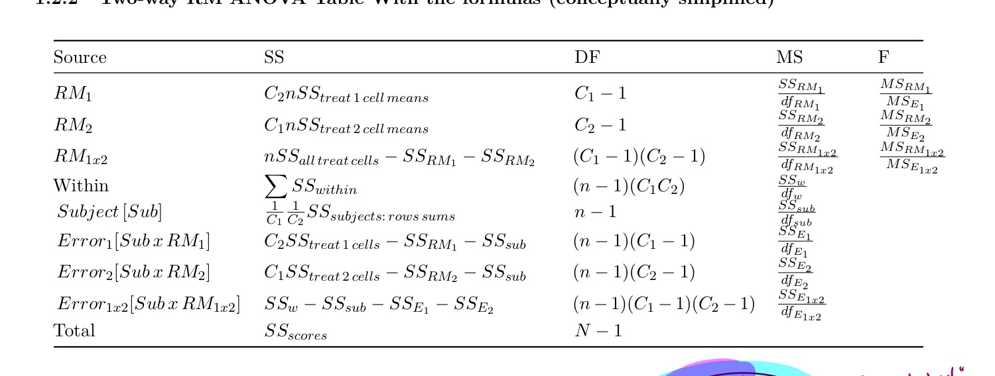

* take the means of the treatment categories of RM1, average the columns, and use the column averages to calculate the sum of squares
* multiply the SS of the column means by n and the number of columns of RM2



* take the means of the treatment categories of RM2, average the columns, and use the column averages to calculate the sum of squares
* multiply the SS of the column means by n and the number of columns of RM1



* take the sum of squares of the means from every column
* multiply it by n
* subtract SS of RM1 and RM2



* add up the sum of squares of every column



* Sum across the rows
* Take the sum of squares of the row sums
* Multiply by 1/number of levels in RM1
* Multiply by 1/number of levels in RM2



* Calculate the sum of squares of all the means of RM1
* Multiply by number of levels of RM2
* Subtract SS of RM1 and Sub



* Calculate the sum of squares of all the means of RM2
* Multiply by number of levels of RM1
* Subtract SS of RM2 and Sub



* The sum of squares of all scores
* OR: SSRM1 + SSRM2 + SSRM1x2 + SSW

**What you should be able to do**

1. Calculate paired t-tests and one and two-way RM ANOVA
2. Be able to select and implement the proper follow-up tests given your hypotheses
3. Be able to unpack an interaction in complex studies
4. Explain the results and follow-up tests in APA format
5. Explain what violating the assumption of RM ANOVA might mean for you results and how to correct for those violations and how they might affect how you do follow up tests